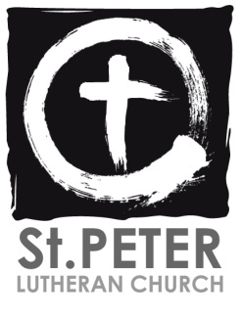 ‘



Join us for our next council meeting   
on **December 7th** at 7pm



Join us for our next Blood Drive on  
**December 20th** from 11:30-5pm

**UPCOMING EVENTS**

    Sunday, November 14 Voter's Meeting in between Services -- Budget and Officers

    Sunday, December 12 Voter's Meeting in between Services -- Budget and Officers



***Weekly Announcements November 14th, 2021***

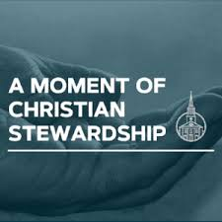



*Thanksgiving Charity Concert – November 20th at 6pm! Bring a canned or non-perishable food item to donate! Collected donations will be split between the Portage Food Pantry and St. Peter’s Food Pantry*

*Thanksgiving Service – We will be having a Thanksgiving service on Tuesday, November 23rd at 7pm.*

*Germanfest Call-Out Meeting – The Committee for Germanfest will be meeting on November 21st between services.*

**Hebrews 10:14 – “For by a single offering he has perfected for all time those who are being sanctified.”** Our Lord Jesus has provided the one offering for sin. What we offer to the Lord is not a sacrifice for sin; we cannot buy our way into heaven with our money, works, or effort. Rather, what we give to the Lord’s work in the Church is a thank offering, a sign of our dependency on God and all He has given us**.**



Envelopes are available at the bulletin table & welcome desk for offerings

General Fund- $1705

*(Weekly need $3,028.00*

*Operating budget)*

*Building Fund-$55*

*(Weekly need $591.00)*



**As we continue to move forward and monitor Covid-19 cases in the area, we ask that people who are still not vaccinated please continue to wear a mask when they attend St. Peter for church or any other event.**

**Thank you for your continued patience and prayers.**

Porter County has entered the **Yellow Alert Level** for Covid-19 transmission. We will ask that people who are not vaccinated continue to wear their masks when they attend Sunday services, or if they visit the building during the week. All others please wear masks at your comfort level.

**Did you know that St. Peter has a food pantry? If you know a congregation member or someone in our community in need, please arrange a pantry visit with the office or visit the pantry on Sunday mornings.**

**If you are able, please consider making a donation! It helps our St. Peter family!**







**Wednesday 11/17**

**Bible Study  
@10am**

**Thursday 11/18**

**Confirmation**

**@5pm**

Robbie Maynard Nov 1

Roni Labonte Nov 3

Jonathan Lehmann Nov 3

Robert Busch Nov 5

Mary Shaw Nov 6

Sherey Shoble Nov 6

Diane Maynard Nov 9

David Nelson Nov 9

Mark Krill Nov 10

Nancy Burcaw Nov 12

Donna Flint-Wood Nov 12

Jeffery Camp Nov 16

Victoria Luster-Bartz Nov 17

Dorothy Graham Nov 18

Frank Lambert Nov 19

Leo Berg Nov 20

Marlene Lepyesh Nov 20

Drake Guerrero Nov 24

Sandra Paloma Nov 24

Cheryl Steinhubel Nov 24

John Carney Nov 25

Jennica Wickhorst Nov 25

Betty Hull Nov 30

*Have a Happy Birthday!*

If for any reason we missed

listing your special day,

please email the church office

.

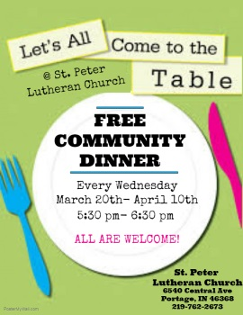

**Sunday 11/21**

**Worship @ 9am &11**

Pray for our civil leaders, health workers, and emergency personnel as they continue to work towards an end to the pandemic. Pray for Dave Gaines, Betty Hull, Ray Parker, Alan Anderson, Carol Riley, Donna Pleasant, Karen Snyder & Family, Candy Gaines, Stacy Carroll, Alice Miller & Family, Judy Anderson, Carl Anderson, Sandy & Vinney Paloma, Dawn White & Family, Tina Gurniewicz, Virgina Galanos, Margie Fites & Family, Dorothy Coons,  John Gallagher, Kristina Thaxton; Ruth Imhof, Donna Flint-Wood & Family, Howard, Deb and Ari Wilson; Joleen Wilson, Linda Lemond and family,  Karen Ackermann,  Bob Busch and family, Pat and John Newlin, Michael Cooper, Kathy Levandoski and her family, Jane Krohn’s family, Pauline & Mark Krill and their family, Joe Blackwell, Wendy Harnung, the Labonte Family, and many people in our congregation who are battling serious illnesses; and those grieving the loss of loved ones. *Have a Prayer Request that you would like St. Peter’s Prayer Chain to know about? Please feel free to fill out a prayer slip on the bulletin table, or email /call the office with your request.*



**Did you know that you can donate to St. Peter on your phone and online?** Visit our website for our online giving page. OrDownload the FREE **Give+** **App** on your phone by visiting your App store. Next, search “St. Peter Lutheran Church” or search by our zip code ‘46368’ and select our Church. Then, log in to your existing account; create a new account **OR** select ‘Give Now’ to give without creating an account. Select which ‘Fund’ you would like to give towards & finally select the amount you’d like to give!

**Subscribe to St. Peter’s YouTube page where you can find all of our recorded services.**



**‘Like’ & ‘Follow’ St. Peter on Facebook!** [**www.facebook.com/StPeterPortage/**](http://www.facebook.com/StPeterPortage/)

**Tune in for our online worship services!**

**‘Follow’ St. Peter Lutheran Church**

**on Twitter!**

**Office Hours M-W-F 8am-12am**

**Phone: 219-762-2673**

**office@stpeterportage.com**

[**www.stpeterportage.com**](http://www.stpeterportage.com)

**Pastor John Albers**

**Cell Phone: 219-241-5765**

**pastor@stpeterportage.com**

**Brad Hughes (President)  
Cell phone: 219-512-3342  
Email: bwhughes@frontier.com**



