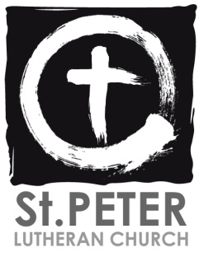 ‘



Join us for our next council meeting   
on **November 9th** at 7pm



Join us for our next Blood Drive on  
**December 20th** from 11:30-5pm

**UPCOMING EVENTS**

    Sunday, November 14 Voter's Meeting in between Services -- Budget and Officers

    Sunday, December 12 Voter's Meeting in between Services -- Budget and Officers



***Weekly Announcements November 7th, 2021***

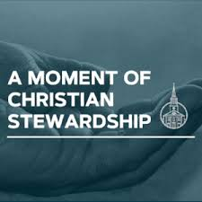



**GermanFest call out meeting on Sunday, November 7th at 3pm!** Come see what’s happening next year, and volunteer to help out! If you have any questions, please see Jillian Speckhard.

**Roadside clean-up project:** We will be sending out a group of volunteers to help clean the roadside on McCool Rd between Central Ave and Route 6 (same as we did in the spring). There is a sign-up sheet in the narthex for volunteers.

**“With angels, archangels, and with all the company of heaven …”** (Service of the Sacraments, Proper Preface). When we gather around the altar of the Lord in His House, we pray and praise God with “all the company of heaven.” Those we have lost in the Lord are not truly lost to us – they have simply entered their rest with the Lord. As we gather to worship our Lord, we gather along with them. On the Last Day, everything that God has given into the care of our stewardship will fade away – everything except our brothers and sisters in Christ. Caring for one another in love and grace is our highest calling.



Envelopes are available at the bulletin table & welcome desk for offerings

General Fund- $1705

*(Weekly need $3,028.00*

*Operating budget)*

*Building Fund-$55*

*(Weekly need $591.00)*



**As we continue to move forward and monitor Covid-19 cases in the area, we ask that people who are still not vaccinated please continue to wear a mask when they attend St. Peter for church or any other event.**

**Thank you for your continued patience and prayers.**

Porter County has entered the **Yellow Alert Level** for Covid-19 transmission. We will ask that people who are not vaccinated continue to wear their masks when they attend Sunday services, or if they visit the building during the week. All others please wear masks at your comfort level.



**Did you know that St. Peter has a food pantry? If you know a congregation member or someone in our community in need, please arrange a pantry visit with the office or visit the pantry on Sunday mornings.**

**If you are able, please consider making a donation! It helps our St. Peter family!**







**Wednesday 11/10**

**Bible Study  
@10am**

**Thursday 11/11**

**Confirmation**

**@5pm**

Robbie Maynard Nov 1

Roni Labonte Nov 3

Jonathan Lehmann Nov 3

Robert Busch Nov 5

Mary Shaw Nov 6

Sherey Shoble Nov 6

Diane Maynard Nov 9

David Nelson Nov 9

Mark Krill Nov 10

Nancy Burcaw Nov 12

Donna Flint-Wood Nov 12

Jeffery Camp Nov 16

Victoria Luster-Bartz Nov 17

Dorothy Graham Nov 18

Frank Lambert Nov 19

Leo Berg Nov 20

Marlene Lepyesh Nov 20

Drake Guerrero Nov 24

Sandra Paloma Nov 24

Cheryl Steinhubel Nov 24

John Carney Nov 25

Jennica Wickhorst Nov 25

Betty Hull Nov 30

*Have a Happy Birthday!*

If for any reason we missed

listing your special day,

please email the church office

.

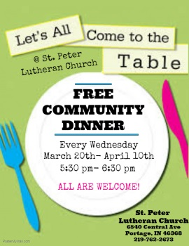

**Sunday 11/14**

**Worship @ 9am &11**

Pray for our civil leaders, health workers, and emergency personnel as they continue to work towards an end to the pandemic. Pray for Dave Gaines, Betty Hull, Ray Parker, Alan Anderson, Carol Riley, Donna Pleasant, Karen Snyder & Family, Candy Gaines, Stacy Carroll, Alice Miller & Family, Judy Anderson, Carl Anderson, Sandy & Vinney Paloma, Dawn White & Family, Tina Gurniewicz, Virgina Galanos, Margie Fites & Family, Dorothy Coons,  John Gallagher, Kristina Thaxton; Ruth Imhof, Donna Flint-Wood & Family, Howard, Deb and Ari Wilson; Joleen Wilson, Linda Lemond and family,  Karen Ackermann,  Bob Busch and family, Pat and John Newlin, Michael Cooper, Kathy Levandoski and her family, Jane Krohn’s family, Pauline & Mark Krill and their family, Joe Blackwell, Wendy Harnung, the Labonte Family, and many people in our congregation who are battling serious illnesses; and those grieving the loss of loved ones. *Have a Prayer Request that you would like St. Peter’s Prayer Chain to know about? Please feel free to fill out a prayer slip on the bulletin table, or email /call the office with your request.*



**Did you know that you can donate to St. Peter on your phone and online?** Visit our website for our online giving page. OrDownload the FREE **Give+** **App** on your phone by visiting your App store. Next, search “St. Peter Lutheran Church” or search by our zip code ‘46368’ and select our Church. Then, log in to your existing account; create a new account **OR** select ‘Give Now’ to give without creating an account. Select which ‘Fund’ you would like to give towards & finally select the amount you’d like to give!

**Subscribe to St. Peter’s YouTube page where you can find all of our recorded services.**



**‘Like’ & ‘Follow’ St. Peter on Facebook!** [**www.facebook.com/StPeterPortage/**](http://www.facebook.com/StPeterPortage/)

**Tune in for our online worship services!**

**‘Follow’ St. Peter Lutheran Church**

**on Twitter!**

**Office Hours M-W-F 8am-12am**

**Phone: 219-762-2673**

**office@stpeterportage.com**

[**www.stpeterportage.com**](http://www.stpeterportage.com)

**Pastor John Albers**

**Cell Phone: 219-241-5765**

**pastor@stpeterportage.com**

**Brad Hughes (President)  
Cell phone: 219-512-3342  
Email: bwhughes@frontier.com**



